**Professional Readiness for Innovation, Employability and Entrepreneurship**  **Project Report for Week 5**

**Project Tile:**  AI-powered Nutrition Analyzer for Fitness Enthusiasts

**Team ID:** PNT2022TMID48053

**GitHub ID:** IBM-Project-53441-1665376120

On September 22nd we had a session on How to view marks , reviews and completed status of our project in ibm account and learned only team leader can assign task to team member in IBM account.

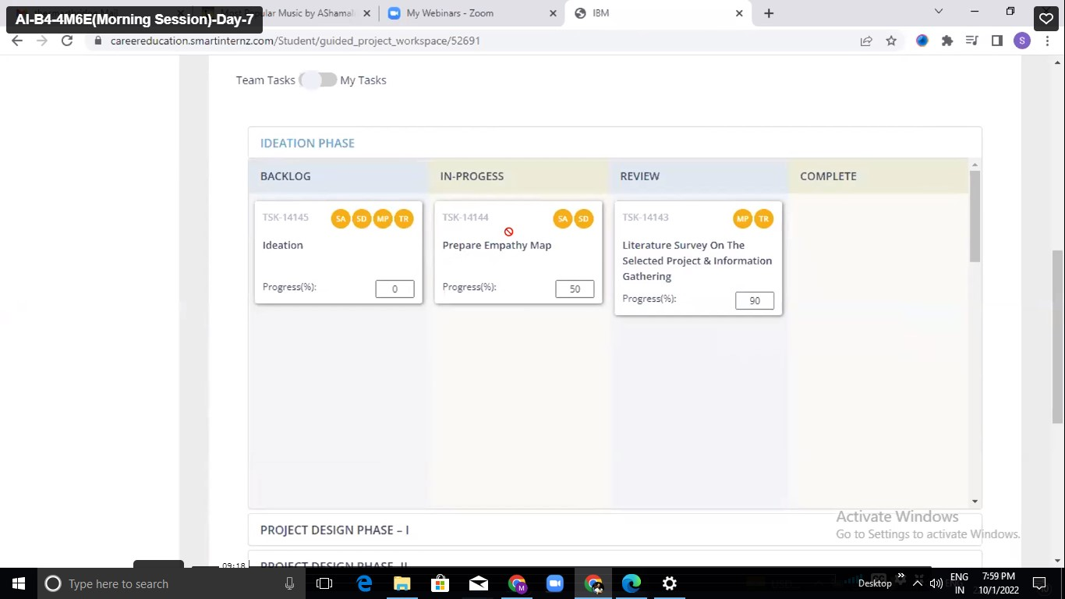

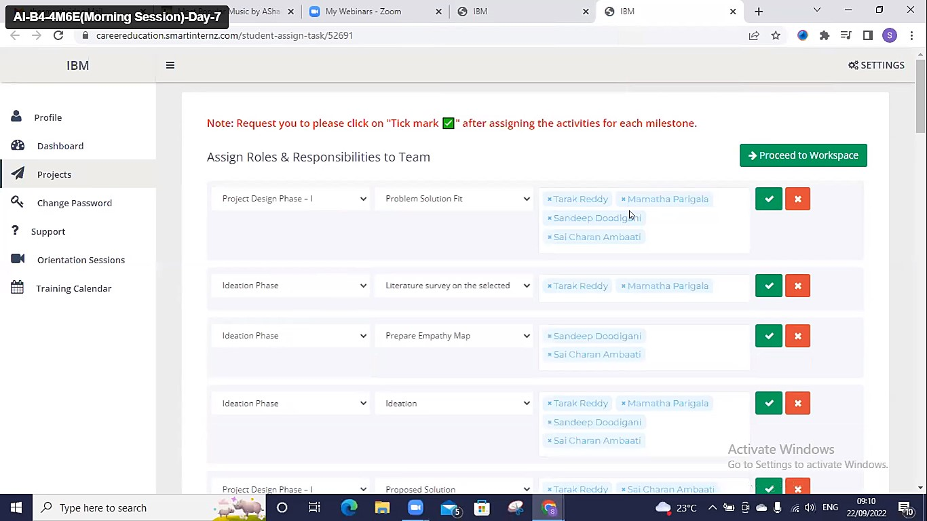

● And learned different types of neural network to implement the program

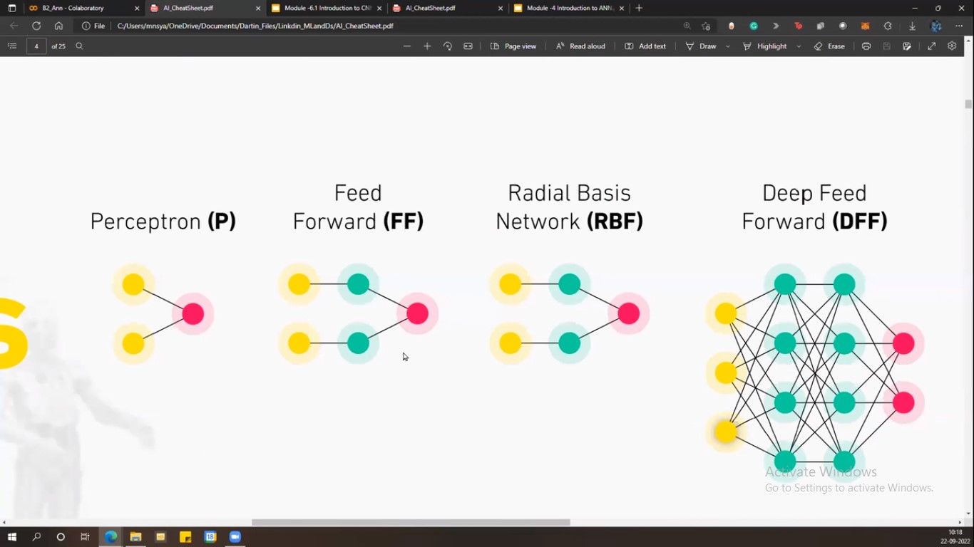

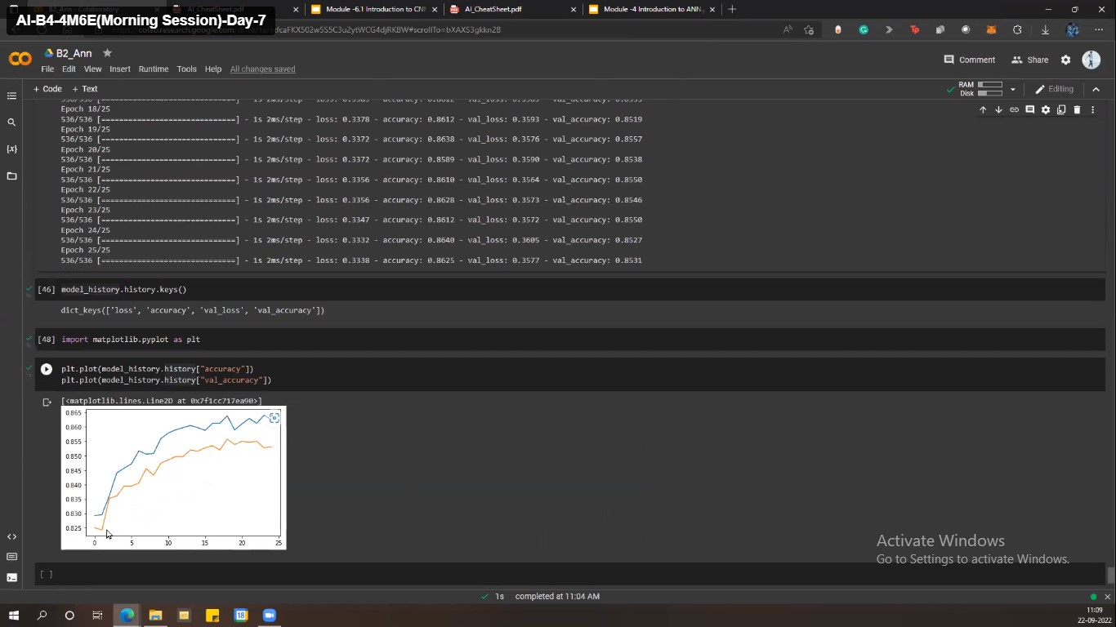

On September 24th we had a session Convontional Neural Network , types of images , CNN layers and case study Animal specific image classification using Convontional neural network.

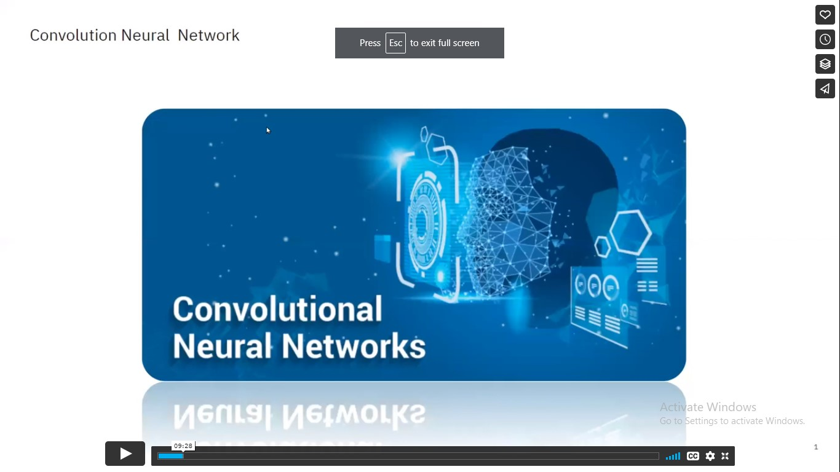

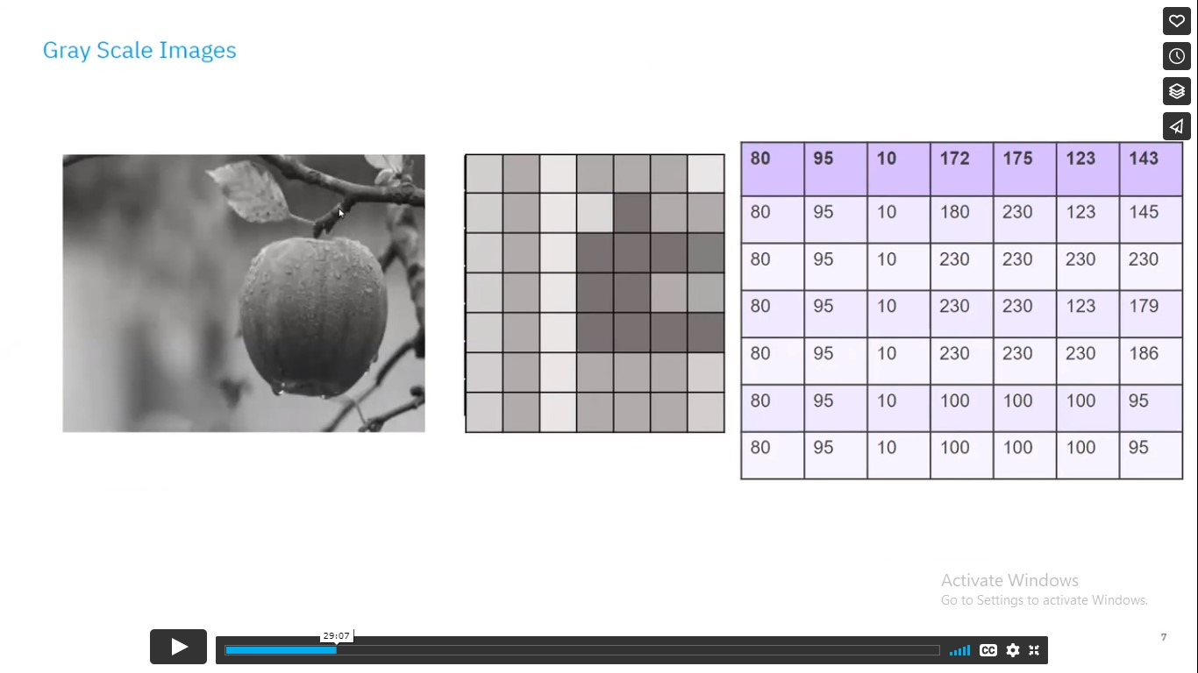

Case Study:

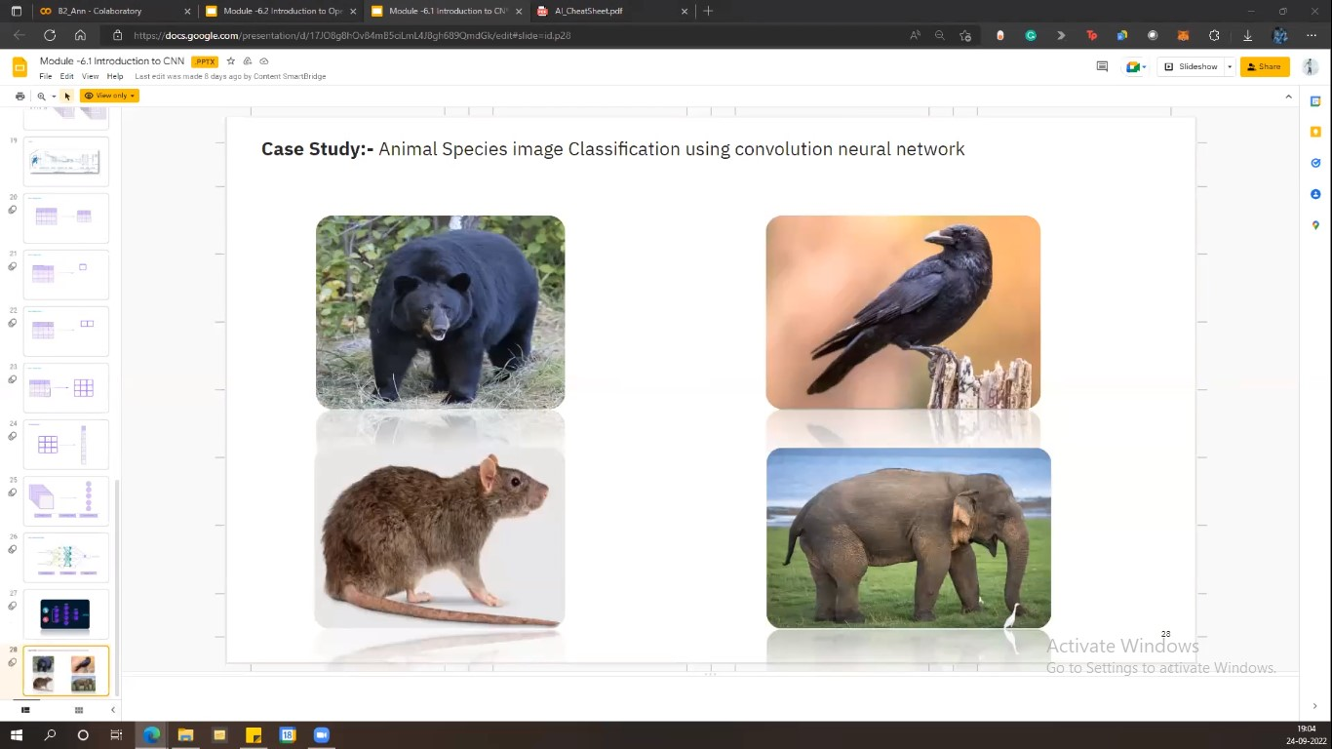

To open CV:

